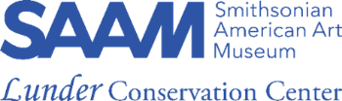
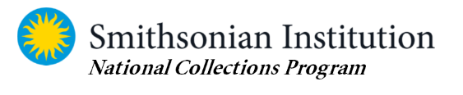
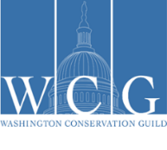
National Collections Program
AND
Office of Safety, Health, and Environmental Management

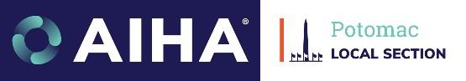

Now accepting Abstracts for the
2023 Safety and Cultural Heritage Summit:
Preserving Our Heritage and Protecting Our Health
Professional Development Seminar

The Potomac Section of the American Industrial Hygiene Association, the Washington Conservation Guild, the Smithsonian Institution’s Office of Safety, Health, and Environmental Management (OSHEM), and the Smithsonian National Collections Program will once again collaborate with the Lunder Conservation Center to host a Safety and Cultural Heritage Summit.

Friday, 27 October 2023 Hybrid Event: In-Person and Streamed On-line

We are now accepting abstracts focusing on controlling health and safety risks from preparing, treating, managing, and exhibiting artistic, historic, and natural science collections as well as abating structural hazards and responding to disasters impacting collections, including challenges of the pandemic. We welcome case studies and action plans, and we encourage joint presentations by conservators, collections care professionals, AND health & safety professionals!

Topics and themes for consideration include but are not limited to:

- Gallery Exhibits: Installation and management safety challenges--working at heights or outdoors; with heavy, large, or hazardous objects; with touchable/interactive exhibits.
- Hazardous Collections: Exposure determinations and risk controls
- Conservation Laboratories and Treatments: safe work policies for object- and material-specific hazards.
- Emergency preparedness and response in collections, with action steps.
- Maximizing sustainability without compromising safety.
- Scalable solutions for small/large institutions or private practices, with small or large budgets.
- NAGPRA Due Diligence: Contaminant Testing, Reporting and Disclosure Policies

Presenters have 3 submission options:
- A podium presentation of 20 minutes, with 5-10 minutes for questions. (30 min. max)
- A lightning round presentation of 5 minutes. Q&A segment may follow as a group.
- A 60- or 90-minute panel with multiple speakers; either time-frame must allow for 15 minutes for speaker/audience discussion. Abstracts must include names of moderator and panelists.

Posters will be accepted only if content can be reduced to a readable 8½ x 11inch or folded 11 x 17 inch sheet handout. There is no available space at the venue for mounted poster presentations.
Abstracts must specify: your submission preference, a provisional title, names and contact information for each submitter, panelist(s) & moderator, and not exceed 400 words. Presentations will be delivered in person.
Questions are welcome! Please send your presentation abstracts to
summit-abstracts@washingtonconservationguild.org by close of business on Tuesday, 1 August 2023.

