Imaging Working Group (IWG) Meeting Notes
October 24, 2023
Introduction and Overview of the Group including Recent Survey Results (Adam Neese, IWG Chair)
- Recent Survey Results – April 2023
  - What initiatives and activities have you enjoyed and would like to see us continue programming for IWG? Mark all that apply.
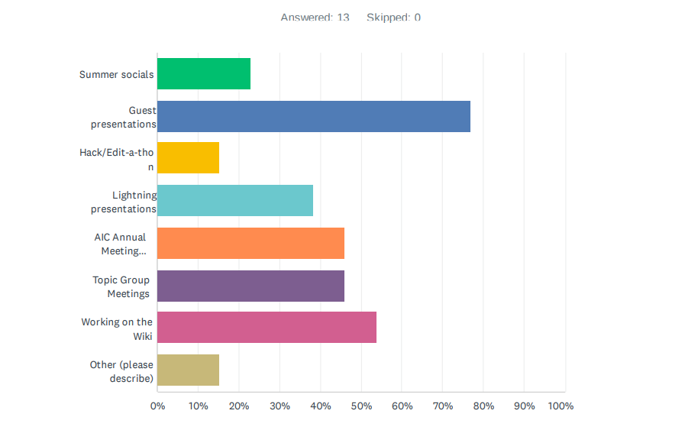
  - Are there initiatives/activities that you feel could be less frequent or improved for future group programming? Mark all that apply.

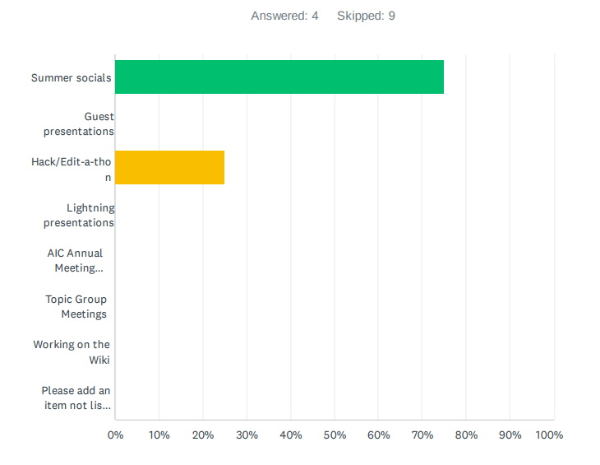
  - Why are you interested in participating with the group? (mark all that apply)
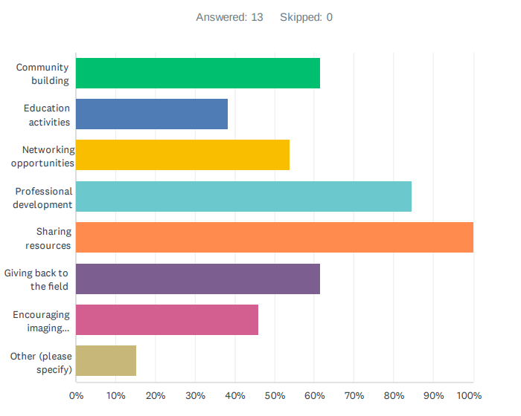
  - Do you feel like the Image Working Group is visible or approachable to non-imaging professionals? For example, are your colleagues aware of it?
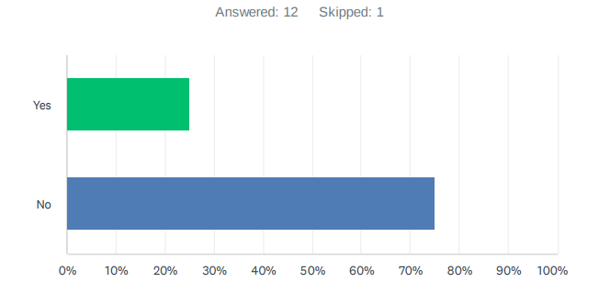
  - Moving forward, how frequently would you like to see group meetings occur?
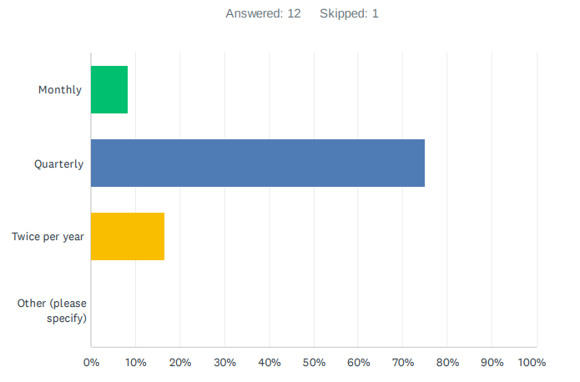

  - Do you feel that you are able to effectively contribute to the group?
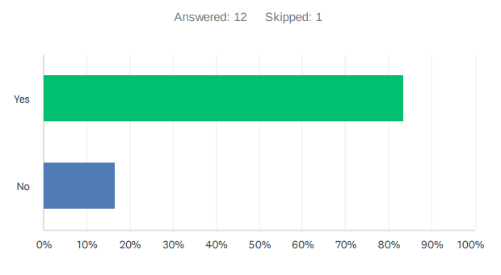
Overarching Discussion Questions:
- What resources do you feel that you do not have accesses? Or what resources do you have that could be beneficial to share?
- What issues are most interesting or topics that create confusion?
- What do you need to be successful with your job? What professional development opportunities would you like to see?
Group Discussion:
- Questions about why people may have left the group – potentially social pressure of having people who have more experience and not wanting to speak up and say something stupid. This may be an issue especially with younger professionals and engaging people who are outside of an institution.
  - Responses: connecting with ECPN; engaging with social media; having pages on wiki about practical things; thinking about different types of engagement; important how you frame it and making sure people feel welcome
- Impact from pandemic and initial engagement of the group with a virtual space and how this ties into the timeline; momentum fell off with the return to office
  - Recognizing that the wiki is a really big project; it is the equivalent of a publication and a really big step
    - Challenges with it needing to say up to date; a huge amount of work
  - Needing to pace ourselves; moving into what we can be collectively instead of setting goals that are so ambitious
- Wanting to connect with colleagues from the wiki groups; is there a better way to do this and having a direct tree of who is in each group?
- Value found in the technique working groups; this was about actively/regularly meeting and working together; challenging to be taking on another writing assignment for the wiki, but the working groups were valuable in working with familiar people and meeting new people
- We started with the wiki which was an objective, but it became a process; main objective of the group should be about maintaining correspondence of the group, sharing ideas – things are moving rapidly, so have a “What’s new this month” in each area
  - Value found in hearing about what is new and going on, sharing ideas, hearing the challenges and the solutions that folks have come up with
  - We should be focusing on maintaining ongoing conversation about what’s happening, challenges, solutions
- Wiki concept could be restructured and point towards forums and conversations in the community; the wiki would have baseline concepts and pointing to forums that are kept up to date
  - Active forum on RTI that has a supporting technical community
  - Forums don’t work for every; the structure of a forum can be daunting to consult and challenging to piece together the information that may be hidden
    - Need a structure of communication that is kept up to date at a frequency that is higher than the IWG’s quarterly meetings; something like LinkedIn Groups; social media platforms have different timelines/immediacy
- Wiki is only one project of the IWG, it has been the collaboration to date, but it is not the only thing. We do other things. To be a long-lasting group, we need to think about what else we want to do.
- What resources do you feel that you do not have accesses? Or what resources do you have that could be beneficial to share?
  - Having a list of research questions that people are working on regardless of position, employment, institution
    - Where is imaging going? What are the open doors that we can explore? Who can we collaborate with?
  - List of projects that people are working on
    - Remembering where you were when you start a project; going to a page to see what someone is working on at the same time
    - How do we think about pulling together these lists without assigning more tasks to members? Is this having a meeting where people share their projects and then we post those summaries from this online?
      - Show and Tell that is not requiring that the project is complete/finished
      - This would not fit into the quarterly meeting cycle, it would need to be more often
    - What do we mean by a project?
    - We would need to indicate the timeline of the project on this list. If it is not timebound, it is harder to engage with this and whether it is an active project.
    - IWG Online Community could be a way to discuss this
      - Social media is good at this; it keeps people engaged and going; these platforms could be helpful
  - ImageMuse – similar conversations, overlap with people and topics in IWG, many people are involved with more than one group
    - valuable professional listserv; people are very willing to share and an incredible resource; topics there do overlap; but it is getting really large; very email oriented, not a forum; over 1200 people worldwide
    - How are we different or similar? The start of IWG and where we saw ourselves in relationship to ImageMuse?
- What issues are most interesting or topics that create confusion?
  - Technology skills and resources – ties into resources; a lot of discussion end with “do you know Python?” “do you know coding?” “web design?”; very dependent on resources or access; very much a growing part of imaging (coding, web design, etc.) – how to solve these issues or where to find solutions or participate in conversations
  - Two-minute lighting talks are valuable
    - Open up the 2-min presentations to a theme or area not just project presentations
      - What questions do you wish you had an answer to? Open questions that people are thinking about, wish they had answers to
  - The people who use images (not as imaging professionals), what do they think of them? How do they use them? What information do they gather? – Not just the conservator using images to map the damage. – Would be interesting to have conversations with the users of images.
  - Example of “Find an Expert” on a university webpage that lists professionals who are willing to engage based on keywords and this is a way to find collaborators on campus
    - This could provide a service and this could start conversations
- What do you need to be successful with your job? What professional development opportunities would you like to see?
  - Communicating better – externally, to the wider public; the right wording and tone to get people interested in this field and this work
  - Showing up and listening; lots of pressure to engage with other professionals; IWG is virtual and does not cost money; this is a big help to check in
  - Having an open Friday meeting; ongoing; anyone can show up and just informal; people can drop in; do not need to have anxiety to show up or be prepared with the meeting – create a hangout, doesn’t have a topic, does not have to have IWG leadership
    - Allow creative juices and informal communication
    - Can find an hour to be available and does not require preparation – this can be easier than preparing a presentation
    - Between professional and chill
    - Good for maintaining relationships
    - Shift in the communication; having some informal opportunities

