Art Installation Instructions

Contempo Track System Information
https://www.ashanging.com/en/contempo-system/

Barrel-end Cables and C-hanger
https://www.ashanging.com/en/barrel-end-stainless-steel-cable/

Total weight capacity for one cable is 45 pounds. NOTE: The hooks used to hang each piece have much lighter weight capacities. For each piece, don’t pass the hook’s weight capacity. See Frame Hooks section. There is a scale in the art closet if needed.

- Insert a C-hanger at the top of the barrel-end cable and hang onto the track.
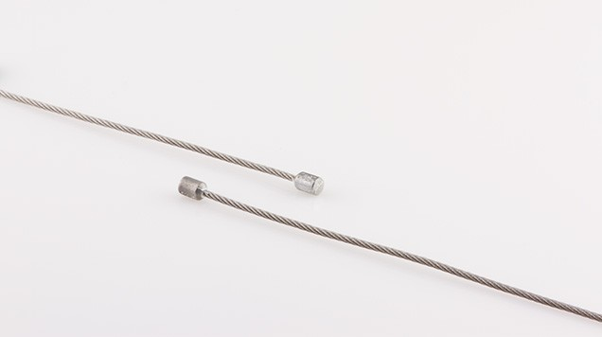

- Use 2 cables per column if you stack art or install larger ones to double weight capacity and offer more stability. Total weight capacity for one cable is 45 pounds.

- Barrel-end cables (what we have) can coil easily in the back of the picture.

- Manufacturer recommends using 2 cables and 2 hooks on items larger than 24” so they hang straight.

Frame Hooks

Secure Gripper Hooks: Use for wires. Weight capacity is 40 pounds.
https://www.ashanging.com/en/secure-gripper-hook/

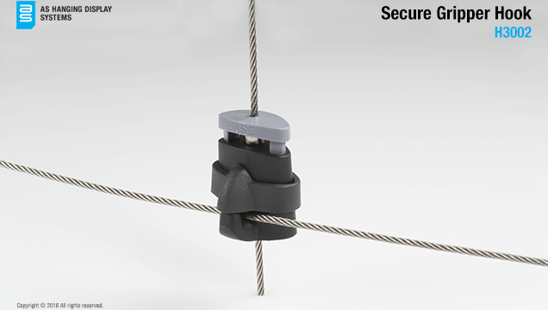

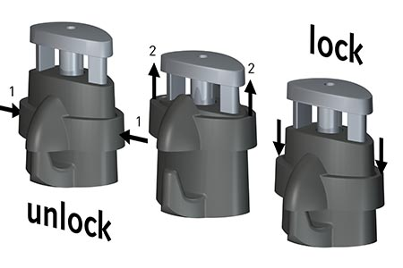

Mini-Hook - Use for Wires. Weight capacity is 12 pounds. Use 2 hooks and cables to double weight capacity.
https://www.ashanging.com/en/mini-hook/

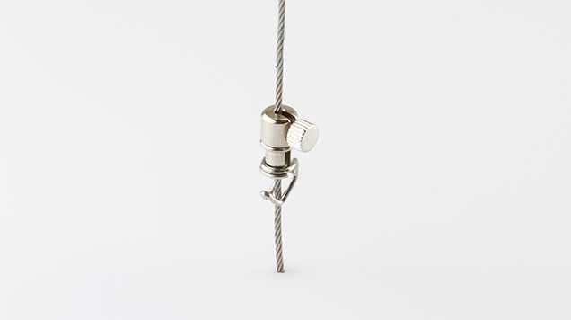

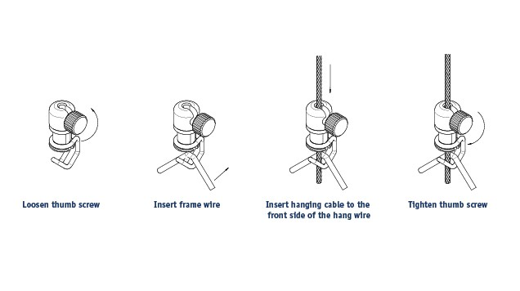

Utility Hook - Use for Sawtooth Hangers. Weight Capacity is 22 pounds. Use 2 hooks and cables to double weight capacity.

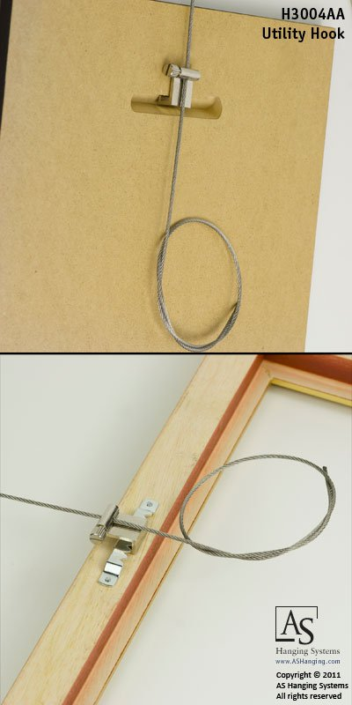

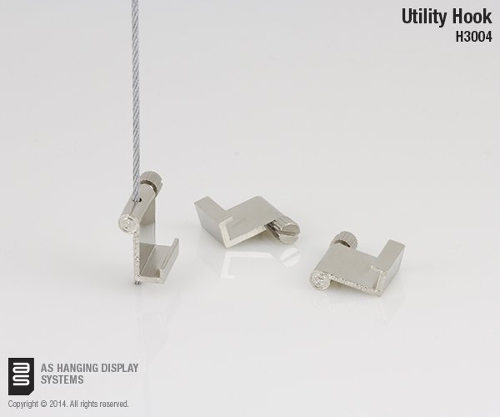

Use Multi-purpose hook - Use for Format Frames. Installs like mini-hook. Weight capacity is 15 pounds. Use 2 hooks and cables to double weight capacity.
https://www.ashanging.com/en/multi-purpose-hook/

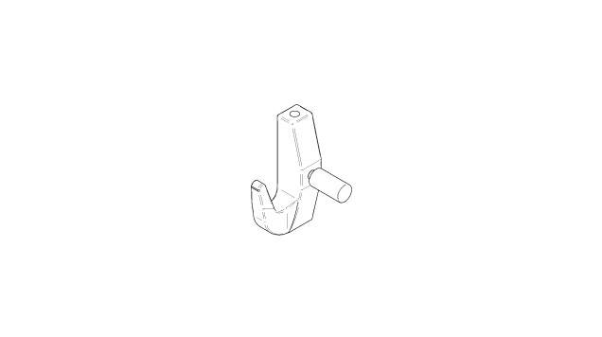
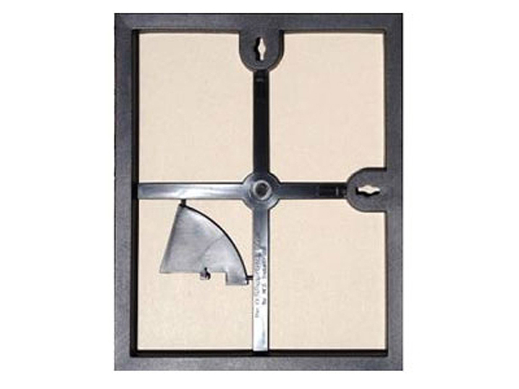

Contempo Track System Installation Instructions
(Students – ignore this page)

To choose length of barrel end cable:
In order to have art at eye level, calculate the height the tracks will be installed and subtract 4 feet. Example: 10 feet - 4 feet = 72 inches.

Do not cut cables because they will fray. Simply coil the excess cable at the back of the artwork.

“Natural” finish should be painted prior to installation. Both track and spaces will oxidize if left unfinished. You would need a metal paint - contact local paint distributor for more info.

Contempo Tracks are 6 feet long (72 inches) & you can easily cut them with a metal saw.
Note they highly recommend to install all Tracks from wall to wall in the entire room. When the Tracks are installed as a continuous line (as a molding) It gives a more refined, finished and harmonious look.

https://www.ashanging.com/en/contempo-track-connector/

The Contempo® can support 78 pounds per track length (6 feet)

